|  |  |
| --- | --- |
| **Group ID** | **A** |
| **Student ID's** | 219501369 |
| 219304092 |
| 219496777 |
| 219509000 |

**AGE ESTIMATION & GENDER CLASSIFICATION**

With Convolutional Neural Networks

**Links:**

[age_gender_A.h5](https://drive.google.com/file/d/1jcG9SqYQcMn2yYU8jPVDG9fRYSB3jEFb/view?usp=sharing)

[age_gender_B.h5](https://drive.google.com/file/d/1-3kSLD6mcwRQ3M3aaM2ZtS-s-d95TNPB/view?usp=sharing)

**Section 1: Introduction**

Convolutional neural networks (CNNs) are regularised multilayer perceptrons and are an integral part of modern deep learning computer vision applications. Considering each pixel as a feature, images have very high dimensionality, hence the convolutional layers in CNNs are very important in dimensionality reduction.

In this project, two CNNs will be trained for gender and age classification, using 5,000 labelled images from the UTKFace dataset. The first model (age_gender_A.h5) will be trained from scratch and the second (age_gender_B.h5) will involve fine-tuning a pre-trained model.

**Section 2: My own CNN**

The images were stratified by equal-sized age bins before splitting into training, validation and test sets to ensure each set had the same distribution of age ranges.

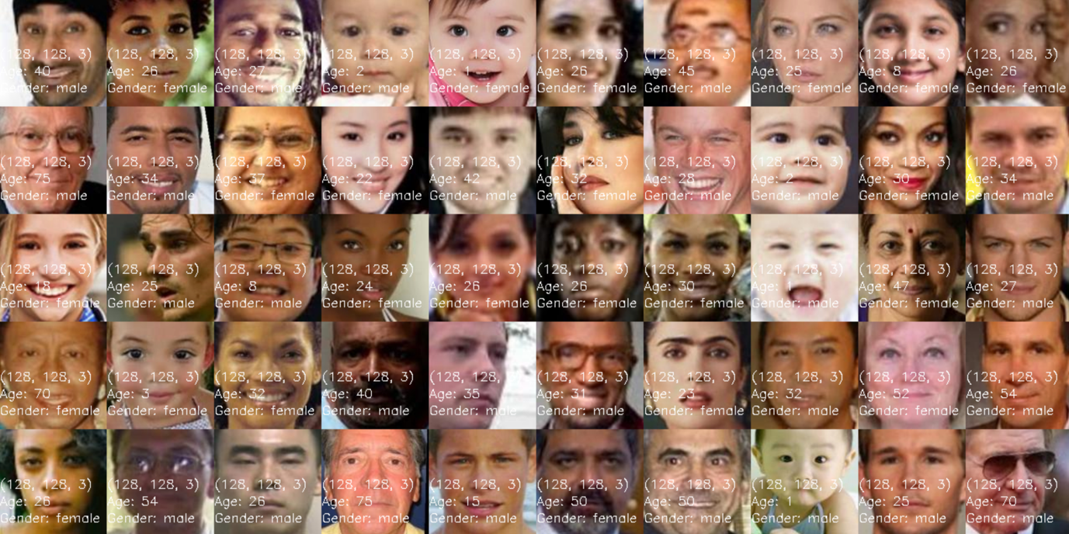

Figure 2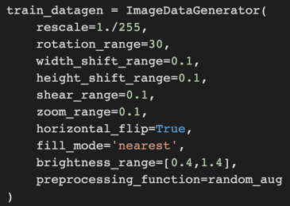: The raw UTKFace dataset.

The training data was then fed into the augmentation pipeline so that for each epoch, the model would receive 4500 unique images during training, generated from ImageDataGenerator.

Figure 3: The random Data Augmentations applied to the training dataset. Additional custom blur transformations were also used.

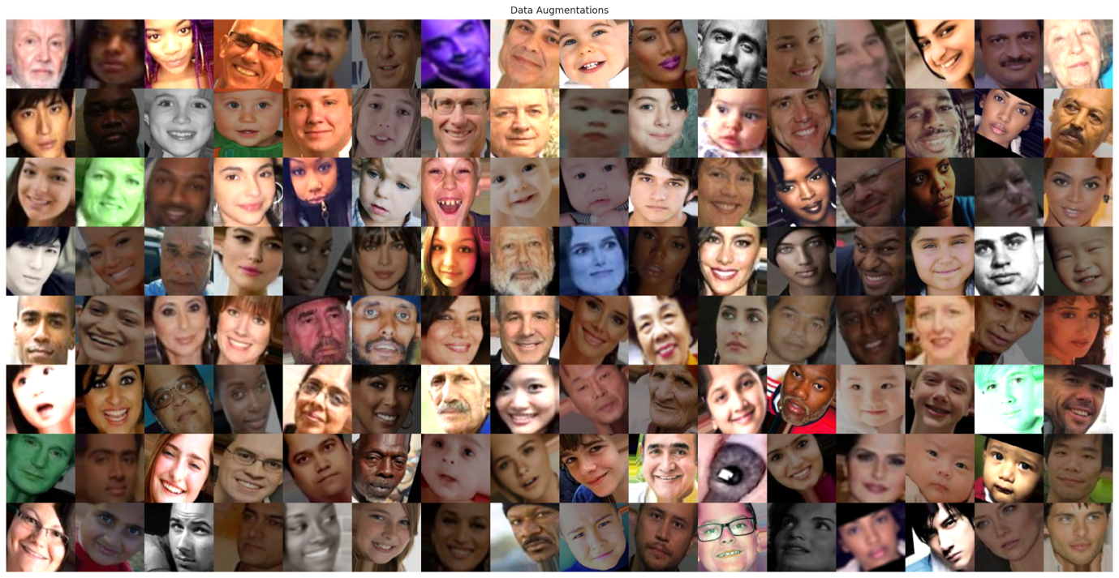

Figure 4: The randomly Augmented dataset.

Data Augmentation is used to prevent the model from memorising the training set and thus overfitting. The validation and test sets both have 250 images reserved, which are unmodified but still rescaled within the range 0 to 1. In the identification of gender from facial images, our model initially splits the age and sex features as different branches in CNN. These two branches are later combined so the model can make better-informed decisions for age prediction based on gender.

For each branch, the following sequence of hidden layers was adopted:

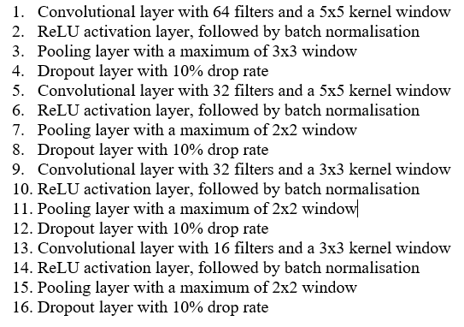

The hidden layer followed the pattern of Convolutional 2D layers, ReLU activation layers, batch normalisation layers, Max pooling layers, and dropout layers. These 5 layers are repeated 4 times, with each time having smaller filters and kernel windows. The pooling layer picks the maximum value of the feature map and passes to the dropout, where 10% of the node is dropped to prevent overfitting. This dropout rate is set at a constant 10%.

In the gender branch, the output of the model is first flattened, followed by:

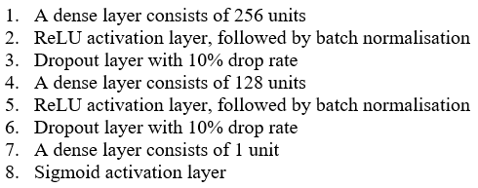

For the gender branch, the final layer is a sigmoid activation function, as gender is defined as a binary output of male and female and hence is a classification problem.

For the age branch, the output from the hidden layer model is first flattened, then:

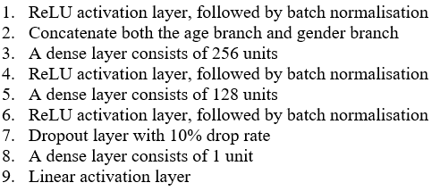

For the age branch, a linear activation function is used instead because age is continuous and hence a regression problem. During the initial training, the initial learning rate is set at 0.008 with epochs at 200 and epsilon at 0.1. These hyperparameters were decided through several trials and errors testing. We chose to use Adam for the optimizer rather than standard Gradient Descent as Adam converges faster which we needed due to limited GPU time. Adam is an algorithm for gradient-based optimization of stochastic objective functions. It combines the advantages of RMSProp and AdaGrad and computes individual adaptive learning rates for different parameters. In figure 6 of the training curve, the model was further trained for another 50 epochs, meaning the total epochs trained were 250.

We chose to minimise the loss for the age branch with the mean squared error and the gender branch with binary cross-entropy. The output metrics chosen were also the mean average error and accuracy respectively.

Our model architecture was inspired by the 2012 ImageNet competition winner AlexNet [1] but scaled down to tackle the given problem efficiently.

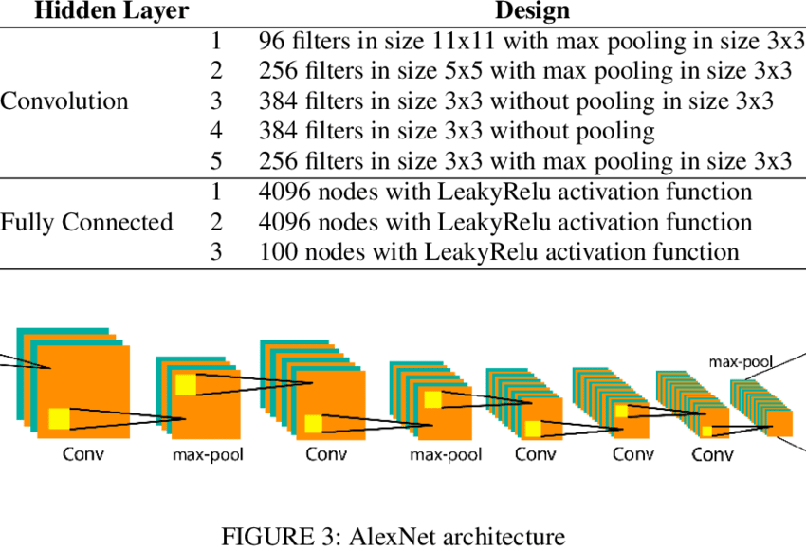

Figure 5: AlexNet architecture.

The result of our validation has an MAE (mean absolute error) of 5.65 years with an accuracy of the gender classification of 94.53%. The test MAE for age is about 4.60 years with an accuracy of gender classification of 92.19%.

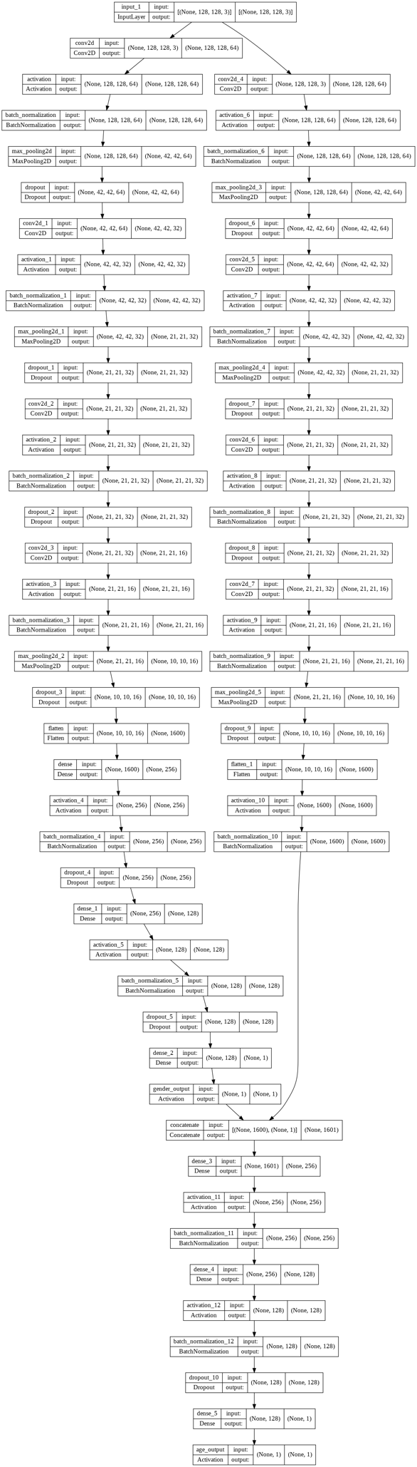

Figure 6: ModelA

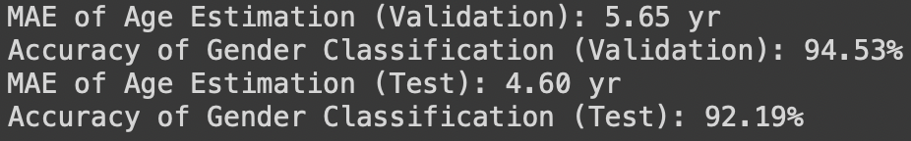

Figure 7: Age MAE and Gender accuracy for our model.

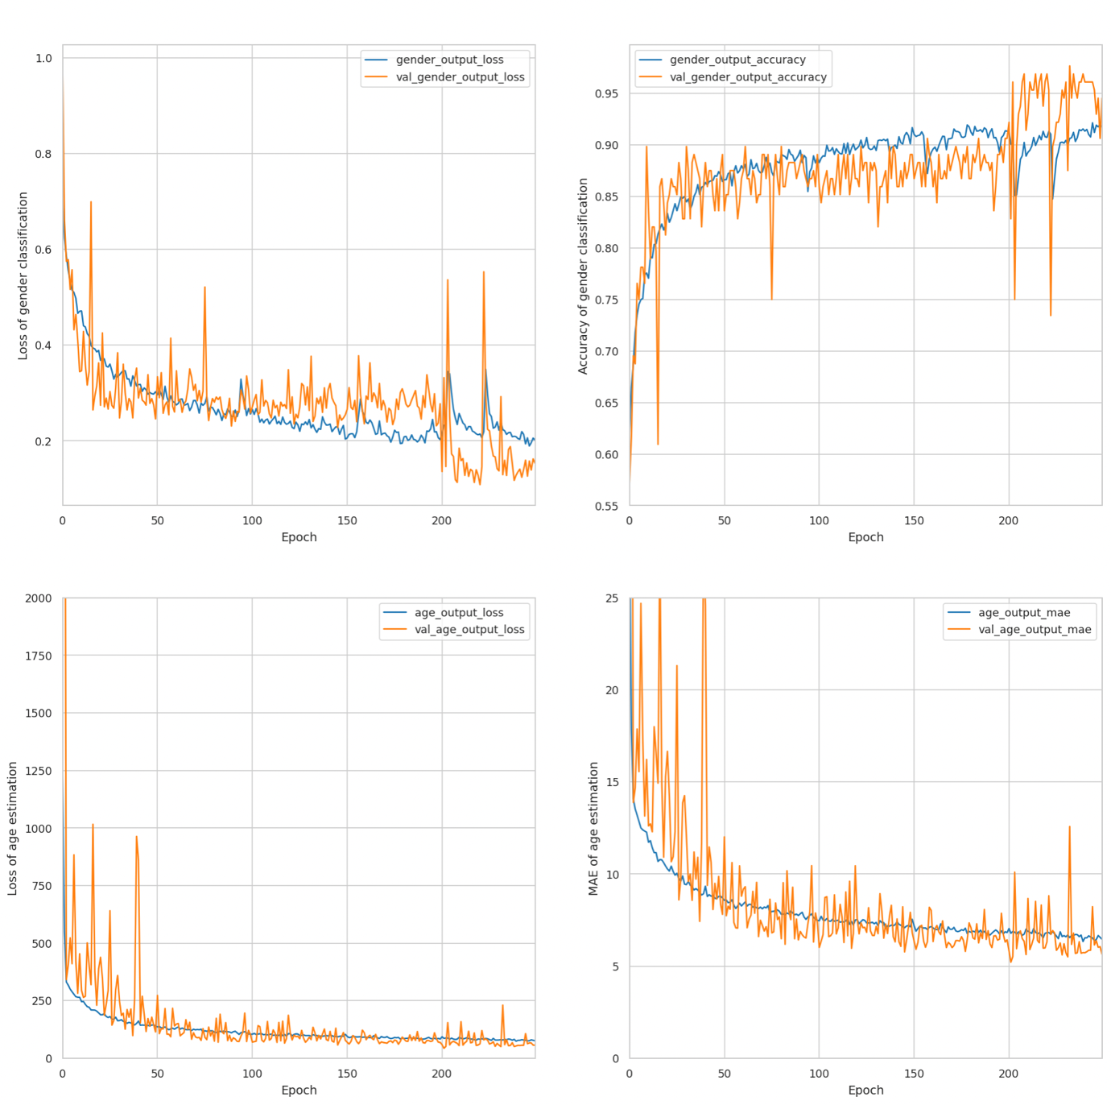

Figure 8: Training/Validation curves.

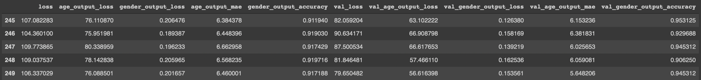

Figure 9: The age and gender loss.

**Section 3: Pre-trained CNN**

In the pre-train part of the CNN, we used Xception, which is a CNN that consists of 71 layers[2,3]. The pre-trained version of this network has been trained on more than 1 million images from the ImageNet itself [4]. We assume that the pre-train CNN would return with much higher accuracy. For the training in this pre-trained CNN, the initial learning rate is set the same as in our CNN with epochs at 150 and epsilon at 0.1. Except for the hidden layer, both the age and gender branch are the same as the one used in our CNN model. Adam is still used as the optimizer in the compiler. The result from this pre-trained model gave an MAE of 8.38 years with an accuracy of the gender classification of 82.03% in the validation model. The test MAE for age is about 8.50 years with an accuracy of 83.59% in gender classification.

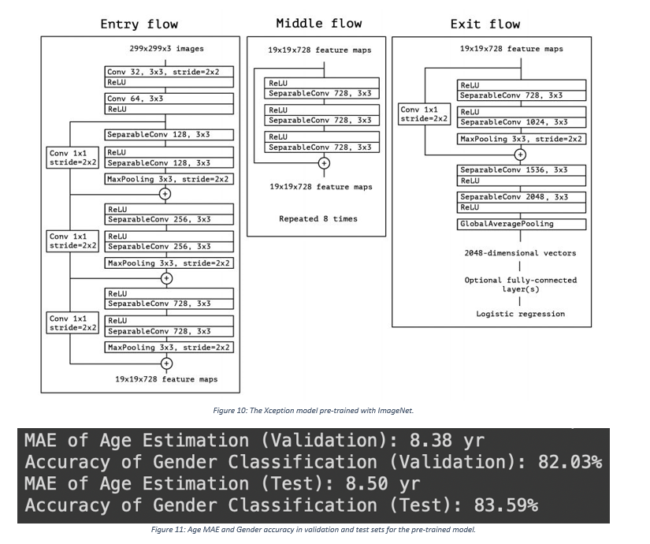

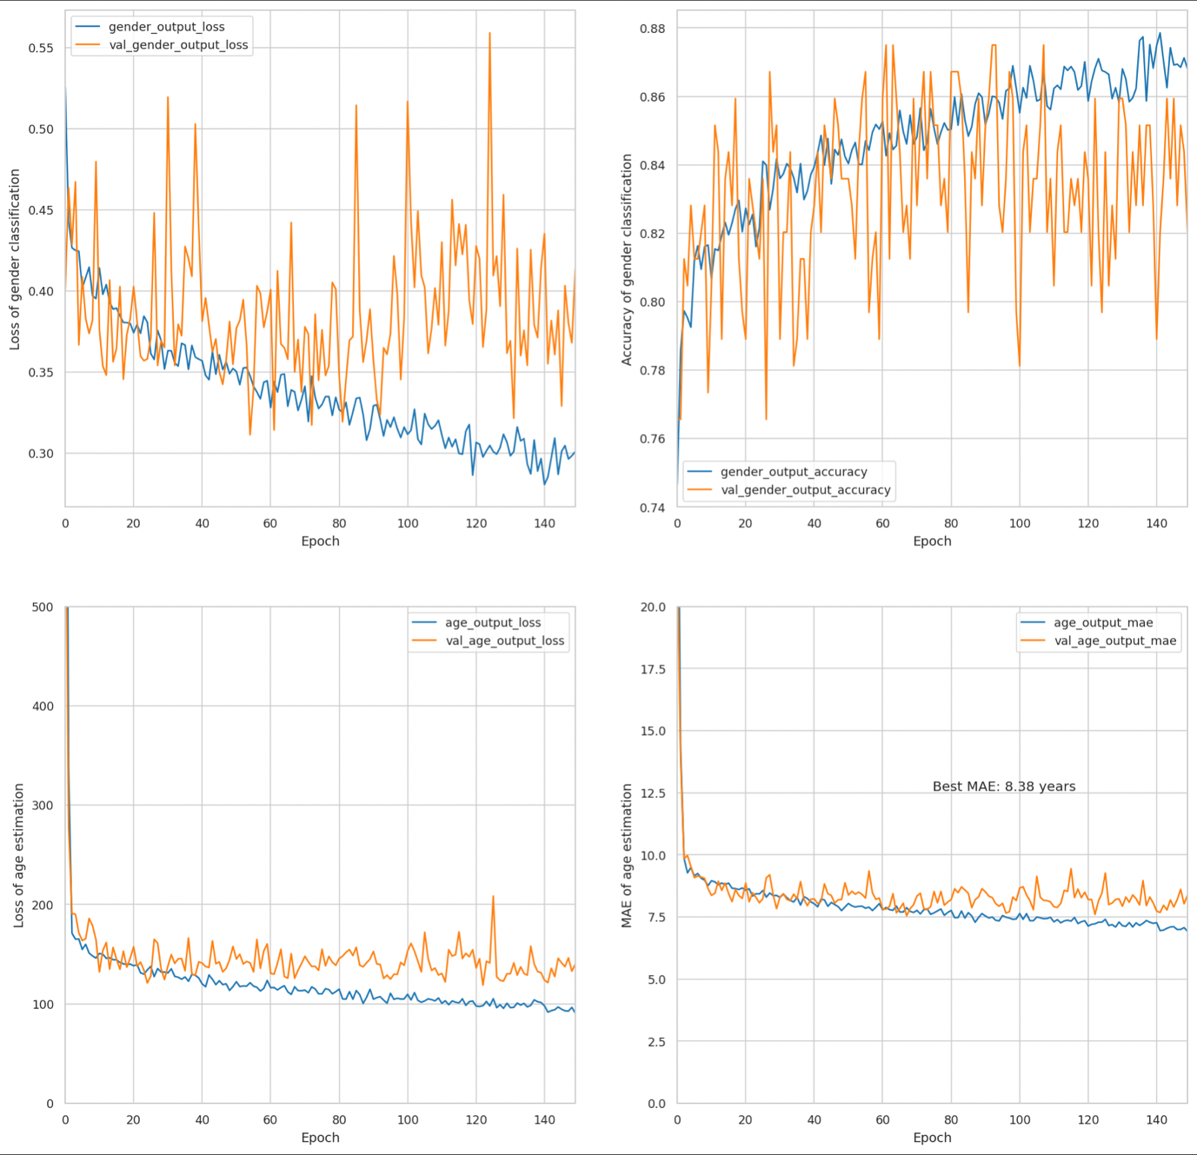

Figure 12: Training/Validation curves for Xception

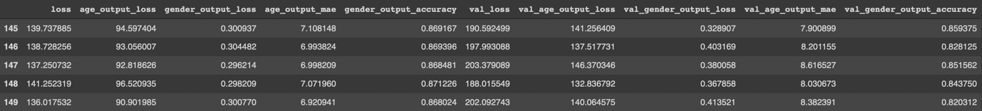

Figure 13: The age and gender loss.

**Section 4: Summary and Discussion**

For the test sets, our model achieved 92.2% gender classification accuracy and 4.60 years MAE for age estimation, while the pre-trained model performed significantly worse, getting 83.6% gender accuracy and 8.50 years MAE for age. This result was surprising but can be explained by the fact the Xception model (pre-trained) is for general object recognition and not solely face/age recognition. In comparison, our model has been adjusted for maximum return in face/age recognition, hence is specialised for this purpose and less generalisable.

For the validation sets, our model returned 5.65 year MAE for age and 94.5% gender accuracy. The pre-trained model had an age MAE of 8.38 years and 82.0% gender accuracy. These results are similar to the test set values, hence one can conclude overfitting was not an issue.

Following a similar architecture to the widely popular AlexNet, albeit scaled-down, proved to be very successful. Considering AlexNet achieved up to 81.4% accuracy in the ImageNet competition, our 92.2% gender accuracy is impressive, although these are not directly comparable. Xception's failings may be due in part to its aggressive downsampling of high-resolution images, potentially losing important information about the original image.

In this assignment, we successfully utilised the power of CNNs for image recognition and used our knowledge of the behaviour of convolutional, ReLU and pooling layers to create a model which outperformed the industry standard Xception by 8.6% for gender classification and an incredible 54% improvement for age estimation MAE. This can be explained by the fact Xception has 71 layers, compared to our model's 41 layers. Given Xception's increased model complexity, more training data is required to utilise its full potential. Otherwise, as seen in this project, Xception is overfitting the training data and hence reducing the accuracy of the test results. As age estimation is a regression problem, a very large sample would be needed to improve Xception's age accuracy.

Given more time, our model could have been improved further by testing more combinations of hidden layer architectures and carrying out greater data augmentation. Further research into attention layers may have also allowed us to adopt them more successfully.

**Reference**

[1] Detail of the AlexNet architecture. ResearchGate n.d. https://www.researchgate.net/figure/Detail-of-the-AlexNet-architecture_tbl1_332333495 (accessed March 20, 2022).

[2] Team K. Keras documentation: Xception n.d. https://keras.io/api/applications/xception/ (accessed March 20, 2022).

[3] Xception: Implementing from scratch using Tensorflow | by Arjun Sarkar | Towards Data Science n.d. https://towardsdatascience.com/xception-from-scratch-using-tensorflow-even-better-than-inception-940fb231ced9 (accessed March 20, 2022).

[4] Xception convolutional neural network - MATLAB xception - MathWorks United Kingdom n.d. https://uk.mathworks.com/help/deeplearning/ref/xception.html (accessed March 20, 2022).